Laptop Hardware

Resources used:
DionTraining UDemy Course - “Laptop Hardware”
A+ Certification Textbook - “Laptop and Mobile Device Hardware”
A+ Certification Classic Textbook - “Portable Computing”

SECURITY COMPONENTS
- Biometric Sensor
  - Allows users to record a template of a feature of their body that is unique to them. In laptops, most commonly implemented as a fingerprint scanner. Many laptops will also allow you to use the webcam for facial recognition technology.
    - You can buy an external USB device w/ fingerprint scanner!
- NFC Scanner
  - Used to pair peripheral devices to a smartphone or tablet; this is typically seen in Apple products - kind of like how I can connect my phone and iPad to my Macbook! (airpods too~).
- Kensington Lock
  - This is just a physical cable that you can use to secure your devices. It’s basically like a bike lock for your laptop, lmao.

LAPTOP HARDWARE COMPONENTS
- Keyboards – Because laptops have way less room to make everything work than a desktop computer, laptop keyboards are generally more compact than their desktop counterparts. For example, the function keys at the very top will usually be found a lot closer to the number keys on a laptop than they are on a desktop keyboard.
- Touchpads – Most laptops feature a touchpad usually located just under the keyboard. You can use it by moving your fingers along the surface, as well as using its buttons just like you would a regular computer mouse, such as right clicking a file to inspect it. If a touchpad has no buttons, then the pad itself will be clickable. Some laptops also have pointing sticks, which are little nubs in the middle of the keyboard that you can push with your finger to move your cursor on-screen.
  - Many manufacturers today include a multitouch trackpad that enables you to perform gestures, or actions with multiple fingers, such as scrolling up and down or swiping to another screen or desktop.
- Screens – Most laptop screens feature a liquid crystal display (LCD), a type of flat-panel display that uses backlit liquid crystals as its primary form of operation. LCD screens are generally the most fragile component of a laptop, and it is for this reason that it is always wise to buy a protective cover or casing for your laptop to provide extra protection. Replacing an LCD screen is not cheap.
  - In most cases, a laptop’s resolution – the amount of pixels the screen is meant to display – will be fixed, meaning that if you change the resolution for any reason, it may not look as crisp as it should, or it might even look outright fuzzy. For example, if a laptop’s native resolution is 1080p and you change the display to 720p or 1440p, what you see with your eyes may look less than ideal.
  - Organic light-emitting diode (OLED) displays are becoming more common on laptops (originally, due to their cost, they were limited primarily to large desktop monitors and TVs). OLED screens sip energy when compared to LCDs, and while less expensive and more common than they used to be, you’ll mostly find them on smartphones and tablets today.
- Power Supply & Batteries – Laptops need direct currents (DC) to charge and operate. Whereas desktop computers often have power supplies built into their cases, laptops don’t have the room, so power conversion must be done on an external device, usually in the form of an AC adapter built into the power cable.
  - In most cases, laptops will feature lithium-ion batteries (Li-ion). Unlike older battery technology, Li-ion batteries do not suffer from a memory effect, meaning you won’t face any consequences if you don’t entirely deplete the battery’s power before recharging it.
  - Every time you charge a Li-ion battery, it will lose a very small amount of its overall life/charging power. Over the years, this diminishing capacity means that it will slowly but surely stop charging as much as it used to, and after enough usage, it will have to be replaced.
- Storage devices – For data storage, desktops most often use a 3.5” hard disk drive (HDD), whereas laptops – in order to try and help save space on the inside – usually use a 2.5” or 1.8” solid state drive (SSD).
  - SSDs have no spinning parts or moving components, instead using newer technology known as flash-based memory that is typically faster and more reliable than the tech found in HDDs. Whereas HDDs have moving parts and make noise, SSDs are silent and perform better overall. Some laptops do still use HDDs, which are capable of holding more information than SSDs.
  - Hard Drive Migration Methods
    - Copying Files Manually: If all that's needed is to get user data from the old device to the new one, then manually copying files is usually an easy option. If the old drive will be inaccessible after the replacement, then files can be copied from the old drive to the cloud or to an external hard drive first. The drive replacement can be made, and then the files copied from the cloud or external drive to the new hard drive. If the old drive will still be accessible, then files can be copied across a network (if conditions permit) or copied from computer to computer with a transfer cable.
      - The downside to this method is that it doesn't transfer any settings or configurations (such as a user's desktop, color scheme, installed printers, etc.), and it normally doesn't work for apps. Apps will need to be reinstalled on the new drive, and the user will have to reconfigure their settings.
    - Using Migration Software Migration: software can move files, settings, configurations, and apps from one drive to another. In most cases for this to work, both drives need to be accessible. For example, the old drive needs to be in a different operational com-puter, in a second expansion slot on the new computer, or otherwise connected, such as through a USB port using a USB-to-SATA adapter. If the connection is available, the migration software can work its magic.
- Central Processing Unit – In laptops, CPUs are designed to be smaller not only so they can fit inside, but so they draw less power and generate as little heat as possible, as laptops are harder to cool than desktop computers. Laptop CPUs often have a lot of other integrated components – such as memory and video controllers – so there are less pieces to be plugged into the system board (creating additional free space, which is vital in any compact device).
- Memory/RAM – Laptops usually feature one of two kinds of memory components: small outline dual in-line memory module (SO-DIMM) or micro-dual in-line memory module (Micro-DIMM). These components are usually held in by clips or hooks that can be popped off before the memory itself can be removed from the slot it’s plugged into.
  - Just as with desktop computers, make sure the SODIMM you want to put into laptop is compatible with the motherboard. The same standards that apply to desk memory compatibility apply to laptops. This means that you can find DDR, DDR2 DDR3, DDR4, and DDR5 SODIMMs for laptops.
- Video cards – Also known as graphics cards, video cards are the main technology responsible for generating output images, or in the case of a laptop, sending imagery directly to the screen. With laptops, video cards are often integrated into the central processor or motherboard, as there is not enough size for regular video cards inside most laptops (as they tend to be quite large).
  - Odds are that the laptop you're using has an integrated video card. If the video card fails, you're likely looking at a motherboard replacement. Very few laptops have a replaceable video card. For those that do, replacing or upgrading it will probably resemble replacing system memory.
- Wireless cards – Most laptops have several wireless adapter cards, sometimes three or more. The most common types are 802.11 wireless connection cards for Wi-Fi, a wireless wide area network card (WWAN) for 3G or 4G signals, and personal area network (PAN) cards for Bluetooth signals.
  - With laptops that include built-in Wi-Fi, the Wi-Fi antenna is generally run through the upper half of the clamshell case. This is to get the antenna higher up and improve signal reception. The wiring will run down the side of the display and through the hinge of the laptop case and plug in somewhere on the motherboard.
    - It's worth repeating again that the Wi-Fi antenna wiring usually runs through one of the hinges of the laptop case. Damage to a hinge can cause Wi-Fi problems. Later in the "Other Internal Components" section, we have an exercise on removing the Wi-Fi card, in which you will disconnect the antenna wires.
- System boards – The backbones of computers that tie all other components into one spot so they can work together in unison. With laptops, system boards are usually customized and specific to each make and model, enabling them to fit inside the unit’s small space along with all the other components. As is the case with most other laptop hardware, this means that if you need to do a replacement, you will need a motherboard that is made specifically for your own laptop. It is also important to note that if any part of the MOBO breaks, the entire component will need to be replaced – meaning that if you do take your laptop apart to add more storage, you must be extra careful to not damage the system board.

Vocabulary
- Digitizer
  - Device that can be written or drawn on, and the content will be converted from analog input to digital images on the computer. Digitizers take input from a user's finger or a writing utensil, such as a stylus. When built into the display, they might be the glass of the display itself, or they might be implemented as an overlay for the display. For touch screen devices, the digitizer might be the primary method of input. For other devices, such as a laptop with a touch screen, users might find the digitizer helpful for capturing drawings or handwritten notes.
- Inverter
  - Small circuit board installed behind the LCD panel that takes DC current and inverts it to AC for the backlight. If you are having problems with flickering screens or dimness, it's more likely that the inverter is the problem, not the backlight itself.
- Aspect ratio
  - The comparison of the screen width to the screen height.

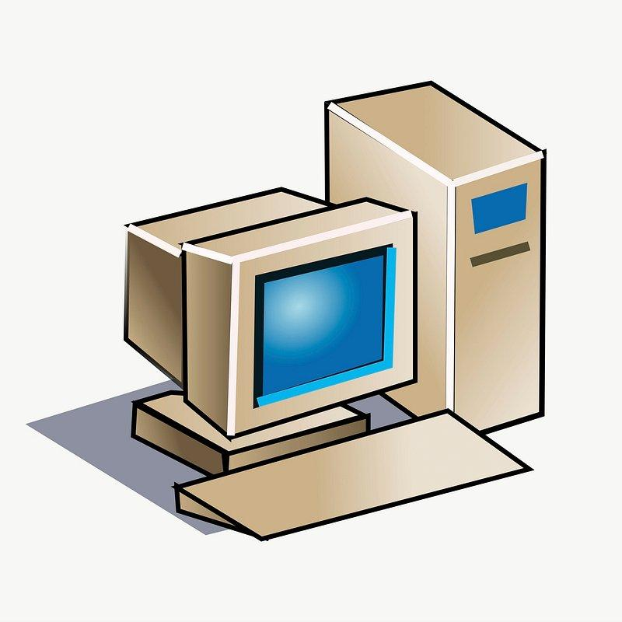In Windows 10/11, this is all contained in the Display area of the Settings app. Open the Settings app and navigate to System | Display. You’ll see a dropdown menu with several options. Extending these displays makes your desktop encompass both the laptop and the external monitor. Duplicating these displays places the same thing on both displays. You’d duplicate these displays for a presentation, for example, rather than for a workspace.

Practice Questions

A client’s laptop appears to boot normally, but nothing ever appears on
the LCD. After closer inspection, you notice the output is visible but it's
too faint to clearly see anything. What is the MOST likely cause of
this issue?

Inverter. The inverter powers the CCFL (Cold Cathode Fluorescent Lamp) LCD
(Liquid Crystal Display) backlight, allowing you to easily view the pixels
on the display. Most newer laptops will use LED (Light Emitting Diode)
backlights with existing DC (Direct Current) power and these LED lights
don’t require an inverter.

The stylus on a Windows tablet will no longer interact with the user
interface. Which of these would be the MOST likely cause of this issue?

The digitizer is the component in a touch screen to convert analog input
from a fingerprint or stylus into a digital input. If the digitizer is having an
issue, then problems will occur with any direct screen input.

